DO-er LIST
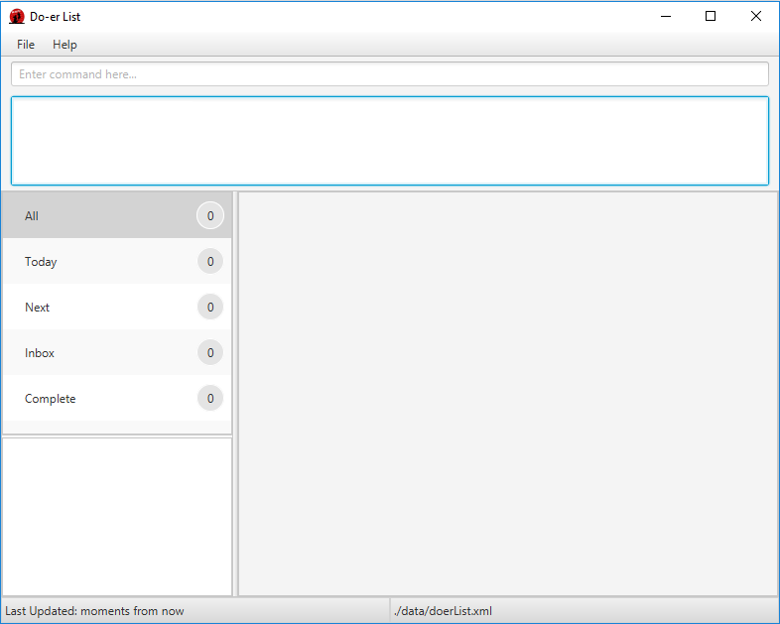
Supervisor: Si Junke Ashley
  Ng Yong Sheng |   Xiao Pu |   Chan Jing Hui Benedict |   Vu Hai Long
Table of Contents
Acknowledgements 3
About Us 4
Supervisors 4
Project Team 5
User Guide 9
About Us 10
Overview 11
Getting Started 12
Features 14
FAQ 31
Command Summary 32
Developer Guide 33
Appendix A: … 33
Appendix B: … 33

Acknowledgements
- Certain aspects of this application were inspired by Marco Jakob’s Java FX tutorial.
- This program utilizes Natty Date Parser under the MIT license.
- This program is based off Address Book Level 4's sample code.

About Us
We are CS2103/T team (Wednesday 09 C4) based in the School of Computing, National University of Singapore.

Supervisors
Damith C. Rajapakse    Role: Module Coordinator | Si Junke Ashley    Role: Project Advisor

Project Team

Xiao Pu

- Components in charge of: UI
- Aspects/tools in charge of: Testing, Integration, JavaFX
- Features implemented:
  - List Tasks
  - Find Tasks
  - View Tasks
  - Delete Tasks
- Code written: [functional code][test code][docs]
- Other major contributions
  - Design UI with Yong Sheng
  - Set up Gradle, Travis, Coveralls and Codacy
  - Help other writing UI parts and GUI test cases for the features they implement.
  - Update Developer Guide to match the project at the end

Yong Sheng

- Components in charge of: UI
- Aspects/tools in charge of: Guides, Balsamiq, Markdown
- Features implemented:
  - Add Recurring Tasks
  - Help Command
  - Exit Program
- Code written: [functional code][test code][docs]
- Other major contributions
  - Design UI with Xiao Pu
  - Help to design and improve the program interface and guides to be more user-friendly
  - Refactors and spot for errors in code comments

Benedict Chan

Role: Developer
- Components in charge of: Storage
- Features implemented:
  - Mark Tasks
  - Unmark Tasks
- Code written: [functional code][test code][docs]
- Other major contributions
  - Collating the UserGuide.md and DeveloperGuide.md with Yong Sheng

Vu Hai Long

- Components in charge of: Logic
- Aspects/tools in charge of: Testing
- Features implemented:
  - Add Tasks
  - Edit Tasks
  - Help Function
  - Task Due
- Code written: [functional code][test code][docs]
- Other major contributions
  - Do the original refractoring.

User Guide

About Us 10
Overview 11
Getting Started 12
Features 14
FAQ 31
Command Summary 32

About Us
Living in the modern and fast-paced world nowadays, we are constantly overwhelmed with tasks to do. Many people face the problem of time management as the traditional methods prove to be little effective. That is what Do-er List aims to solve.
Do-er List is a task manager that is designed for students and office workers. It is a beginner-friendly desktop program that aids you in the planning and completion of your daily tasks. It does not matter if you are planning a big birthday surprise event or recurring task of handling the laundry every now and then, Do-er List is here to resolve your problems.
This user guide aims to allow any user to seamlessly use the product, as intended to. Just follow the instructions as stated and you will get the results you desire.
Eager and excited? Then let us proceed!

Overview
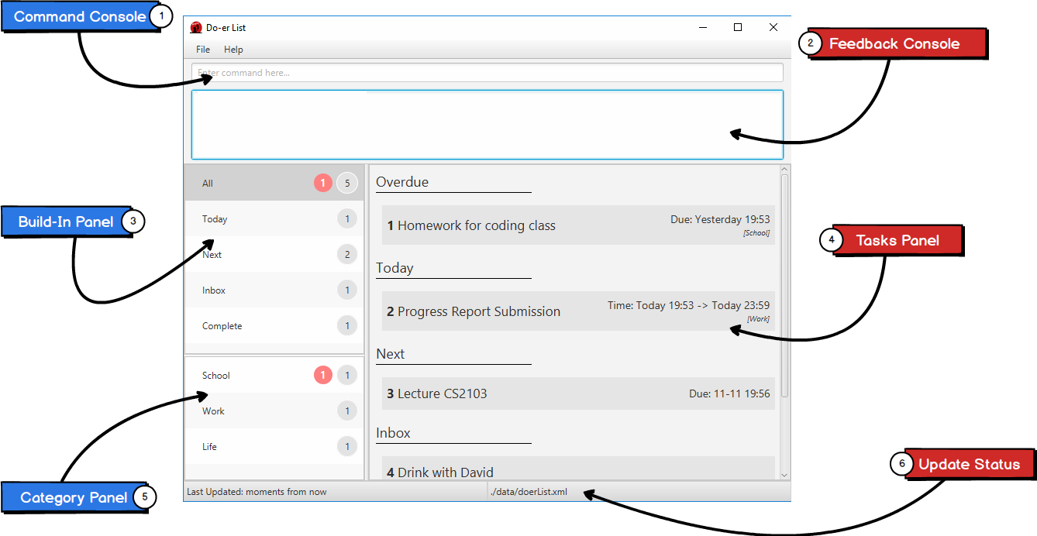
Labels | Description
1 | Type your commands in the Command Console to execute the desired commands.
2 | Feedback Console shows if your command is executed properly or not.
3 | View your build-in categories in the Build-In Panel.
4 | Tasks Panel will display all the tasks you listed in a panel.
5 | Category Panel shows all the custom categories that you have created.
6 | View your last update and file storage in Update Status.

Getting Started
Do-er List makes the process of adding, editing or deleting tasks a seamless process. Long gone are the days when you need to type in long and complicated commands or endlessly click on multiple buttons to get what you desire.
All commands have this standard format:
Command required_fields [optional_fields] ...
All commands start with a command words, followed by fields that are replaced by your inputs. The fields in the square bracket "[" and "] are optional. You can choose to not include these fields.
Please take note of the following:
- Ensure you have Java version 1.8.0_60 or later installed in your Computer.
> This app will not work with earlier versions of Java 8.
- Download the latest doerlist.jar from the releases tab.
- Copy the file to the folder you want to use as the home folder for the Do-erList.
- Double-click the file to start the app. The GUI should appear in a few seconds.
- Type the command in the command box and press Enter to execute it.
  - e.g. typing help and pressing Enter will open the User Guide in a new window.
- Some example commands you can try:
  - add/t Do post-lecture quiz /s today 10:00 /e tomorrow 12:00 /c CS2103: adds a task called Do post-lecture quiz to the Do-er List that starts today at 10:00 and ends tomorrow at 13:00 under the category CS2103.
  - list CS2103: lists all tasks in CS2103
  - delete 1: deletes the 1st task shown in the current list
  - exit: exits the application
- Refer to the Features section below for details of each command.

Features
Command Format
- Words in UPPER_CASE are the parameters.
- Items in SQUARE_BRACKETS are optional.
- Items with ... after them can have multiple instances.
- If a command has multiple parameters, the order of parameters doesn't matter.

Viewing help: help
Format: help or help [COMMAND_NAME]

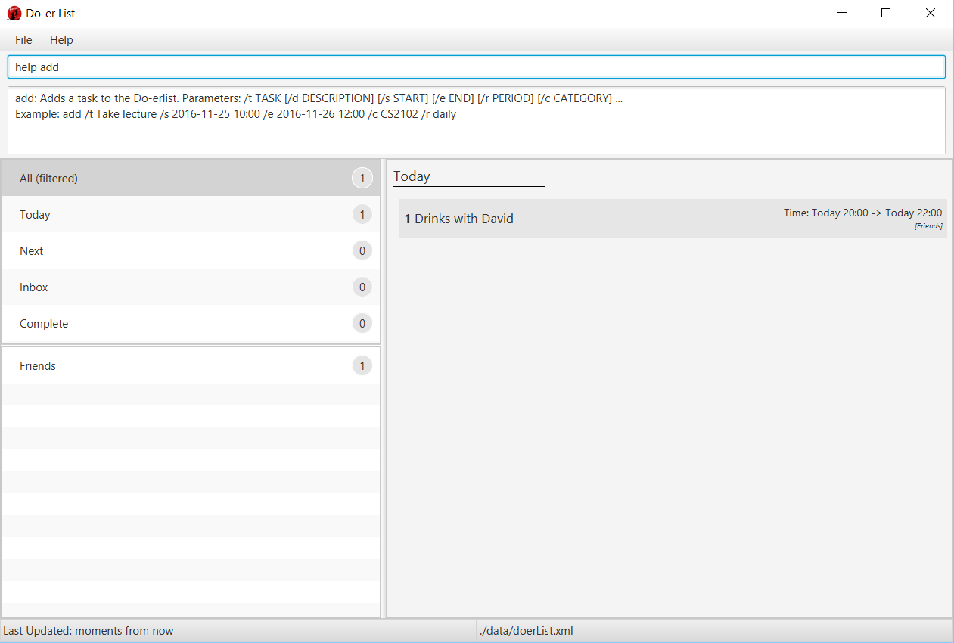
If the COMMAND_NAME is supplied, it will display the instructions of using that command.
Help is also shown if you enter an incorrect command e.g. abcd

Adding a task: add
Adds a task to the Do-erList
Format: add /t TITLE [/d DESCRIPTION] [/s START] [/e END] [/c CATEGORY]
[/r RECURRING]...

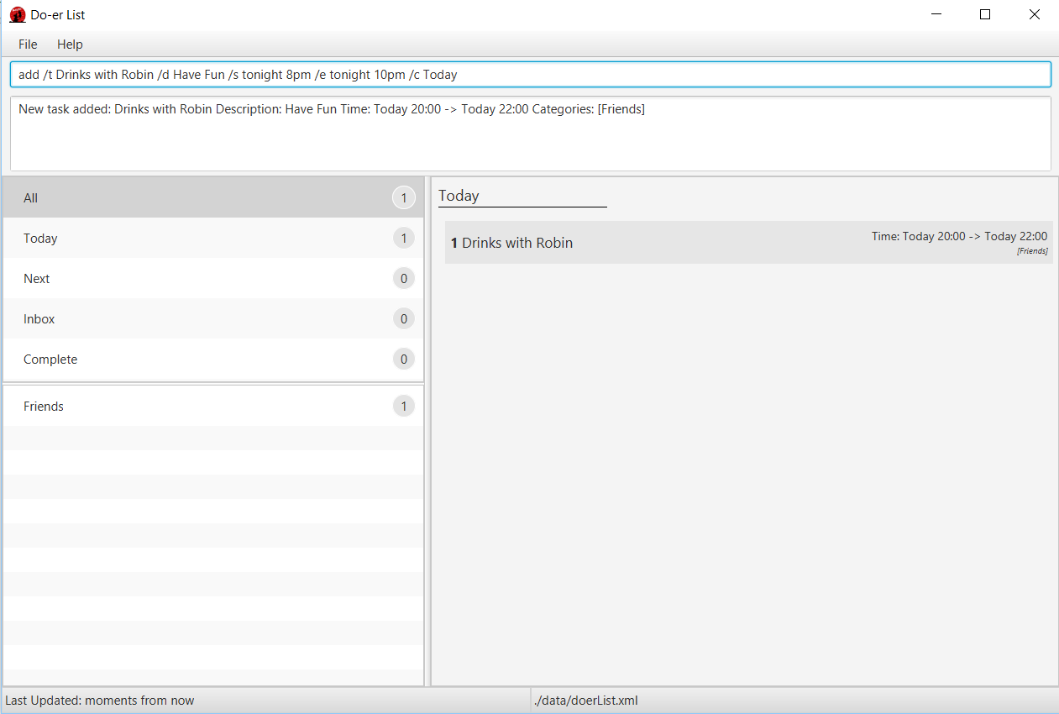
- You can choose to have no categories or any number of them in your task.
- The START or END parameter supports natural language input.
- RECURRING intervals can also be added in and supports in natural language input.
- If the START date is missing, the Doer-List set it to its current timing and date by default.
- If there is no START or END parameters, the Doer-list will create task without start date and end date and move it to Inbox default category.
- Supported list for natural language for START and END:
  - next X hours / days / weeks / months
    - X can be any number: 1, 2, 3, ...
  - today
  - tomorrow
  - next week / month
- Supported list for natural language for RECURRING tasks:
  - daily
  - weekly
  - monthly
  - yearly
Examples:
- add /t Weekly Laundry /s 2016-11-23 21:00 /c Chores
- add /t Daily Exercise and Workout!
- add /t Call Mum in Hanoi /d Limit chat timing for overseas charges /s tomorrow 8pm /e tomorrow 10pm /c Optional
- add /t Check Email /s tomorrow 8pm /e tomorrow 10pm /r daily

Editing a task: edit
Edit an existing task in the Do-er List
Format: edit INDEX [/t TITLE] [/d DESCRIPTION] [/s START] [/e END] [/c CATEGORY]
[/r RECURRING]...

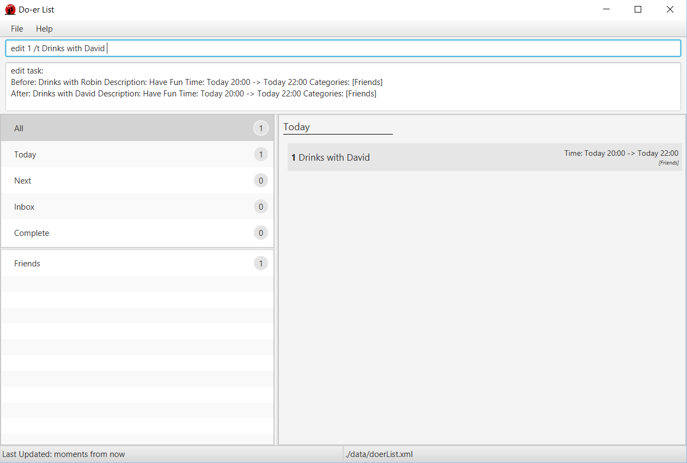

Edit an existing task by calling its index. The task's title, description, start date, end date, recurring intervals and categories can be edited.
Examples:
- edit 2 /t Do the Laundry /c Chores /r Daily
- edit 3 /c Do Homework
- edit 3 /s tomorrow 23 00
Attributes that are not supplied will not be updated

Mark task as done: mark
Marks a certain task as done in the Doer-list.
Format: mark TASK_NUMBER

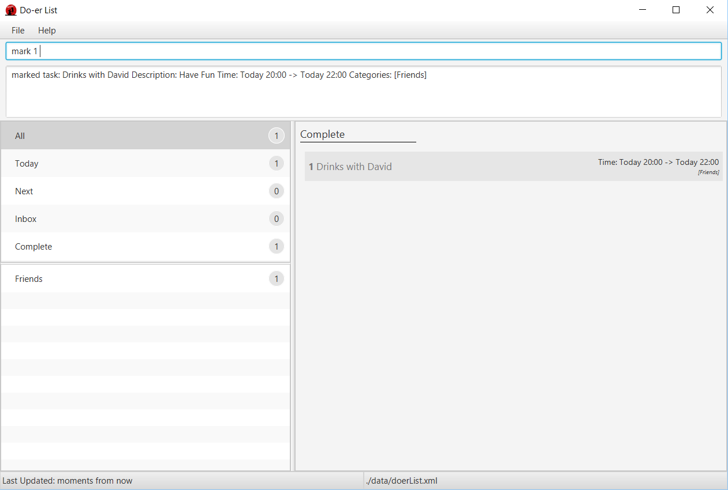
Mark task TASK_NUMBER as done. The task must exist in the Doer-list.
Examples:
- mark 5
  - Returns task number 5 as done.
  - If a recurring task is mark is done, it will automatically update its start and end date.

Unmark task as done: unmark
Marks a certain task as undone in the Doer-list.
Format: unmark TASK_NUMBER

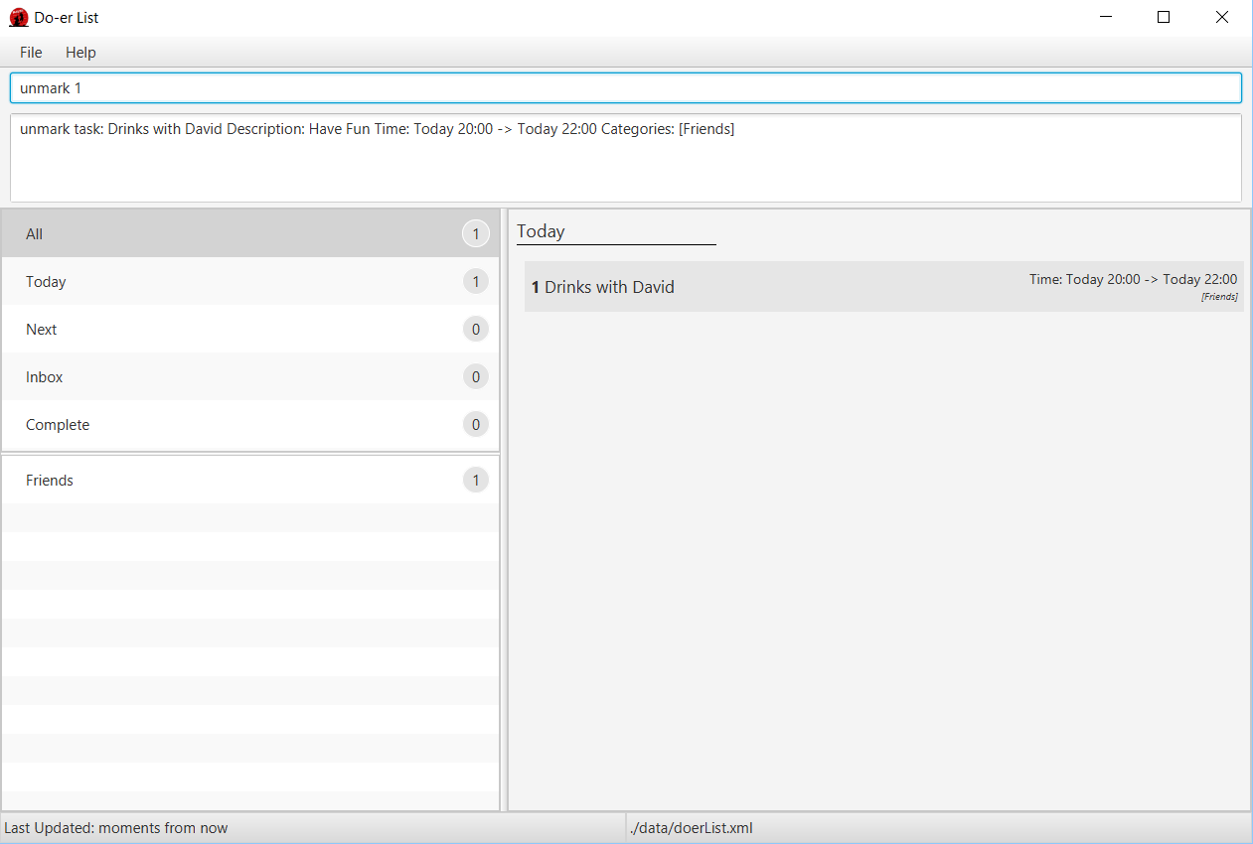
Mark task TASK_NUMBER as undone. The task must exist in the Doer-list.
Examples:
- unmark 5
  - Returns task number 5 as undone.
  - If a recurring task is mark is unmarked, it will automatically subtract its start and end date by its given recurring interval.

Listing tasks in a certain category: list
Shows a list of all tasks in the Doer-list under the specific category.
Format: list [CATEGORY]

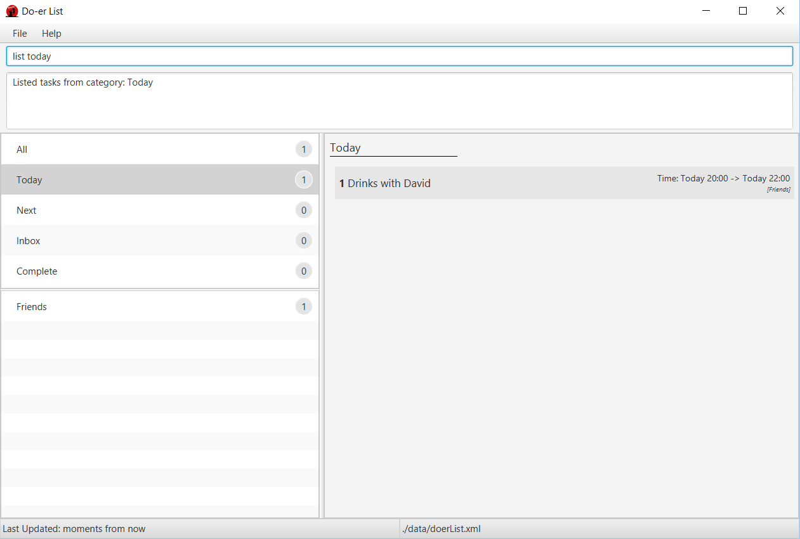
- If the CATEGORY or DATE parameter is not supplied, then it will list all tasks.
- Some build-in categories: All Today Next Inbox and Complete can be also listed.
Examples:
- list
- list Friends
- list today
- list next

Finding all tasks containing any keyword in their name: find
Finds tasks whose names contain any of the given keywords.
Format: find KEYWORD [MORE_KEYWORDS]

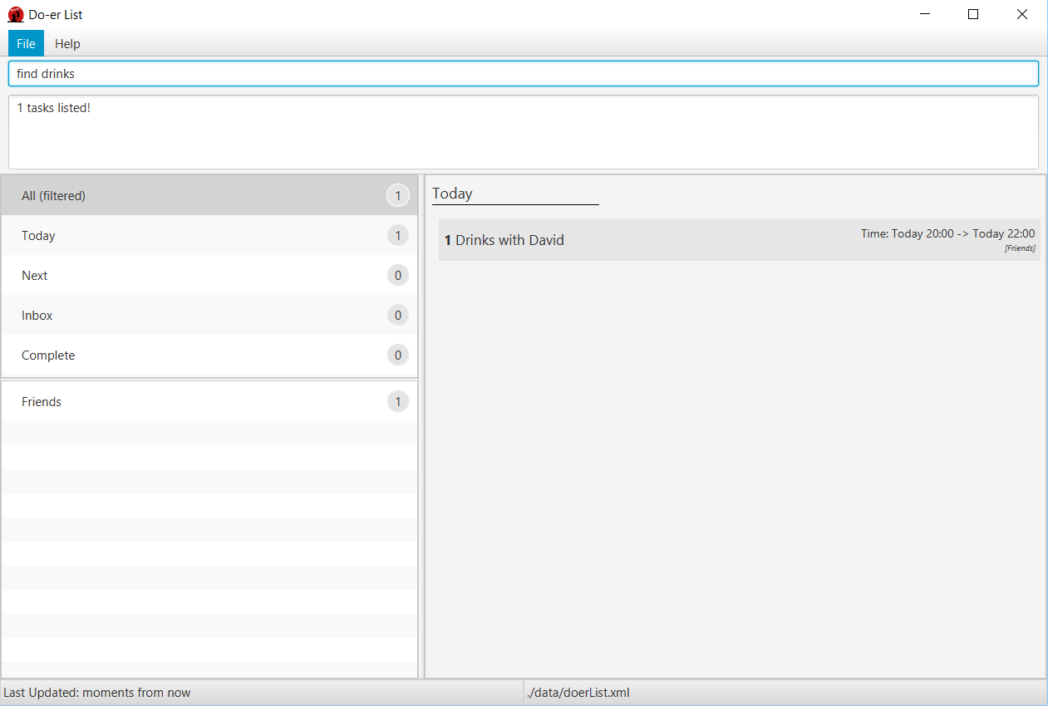
- The search is not case sensitive.
  - lecture will match LecTure
- The order of the keywords does not matter.
  - go to lecture will match Lecture go to
- Title and Description is searched.
- All data in the Do-er List matching at least one keyword will be returned
  - lecture will match have lecture
Examples:
- find david
Returns Drinks with David

View a task: view
Views the task identified by the index number used in the task panel.
Format: view INDEX

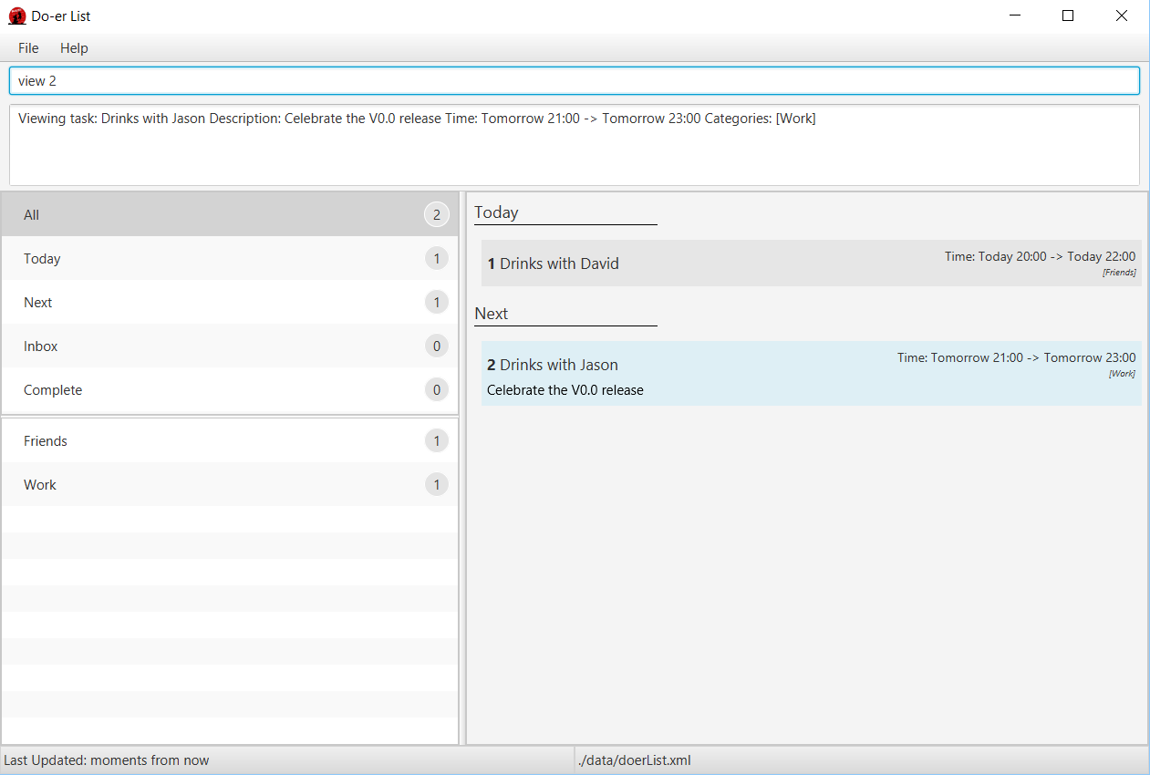
- Views the details of the task at the specified INDEX.
- The index refers to the index number shown in the most recent listing.
The index must be a positive integer 1, 2, 3, ...
Examples:
- list
view 2
Views the 2nd task in the Doer-list.
- find David
view 1
Views the 1st task in the results of the find command.

Deleting a task: delete
Deletes the specified task / event from the Do-erList.
Format: delete INDEX

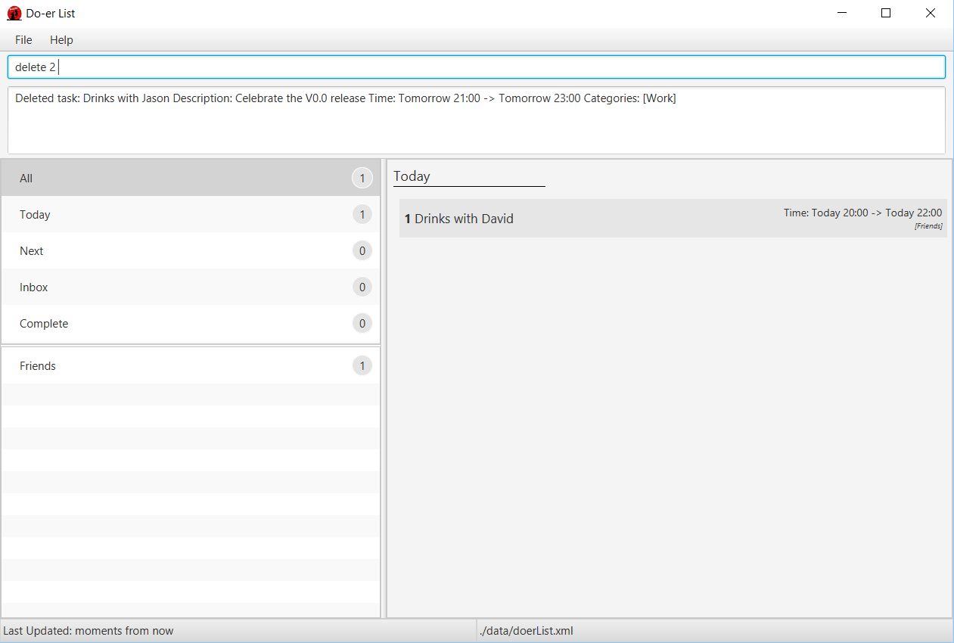
- Deletes the task / event at the specified INDEX.
- The index refers to the index number shown in the most recent listing.
The index must be a positive integer 1, 2, 3, ...
Examples:
- list
delete 2
Deletes the 2nd task / event in the Do-erList.
- find David
delete 1
Deletes the 1st task / event in the results displayed by using the find command.

Undo the most recent operation: undo
Undo the most recent operation which modify the data in the Doer-list
Format: undo

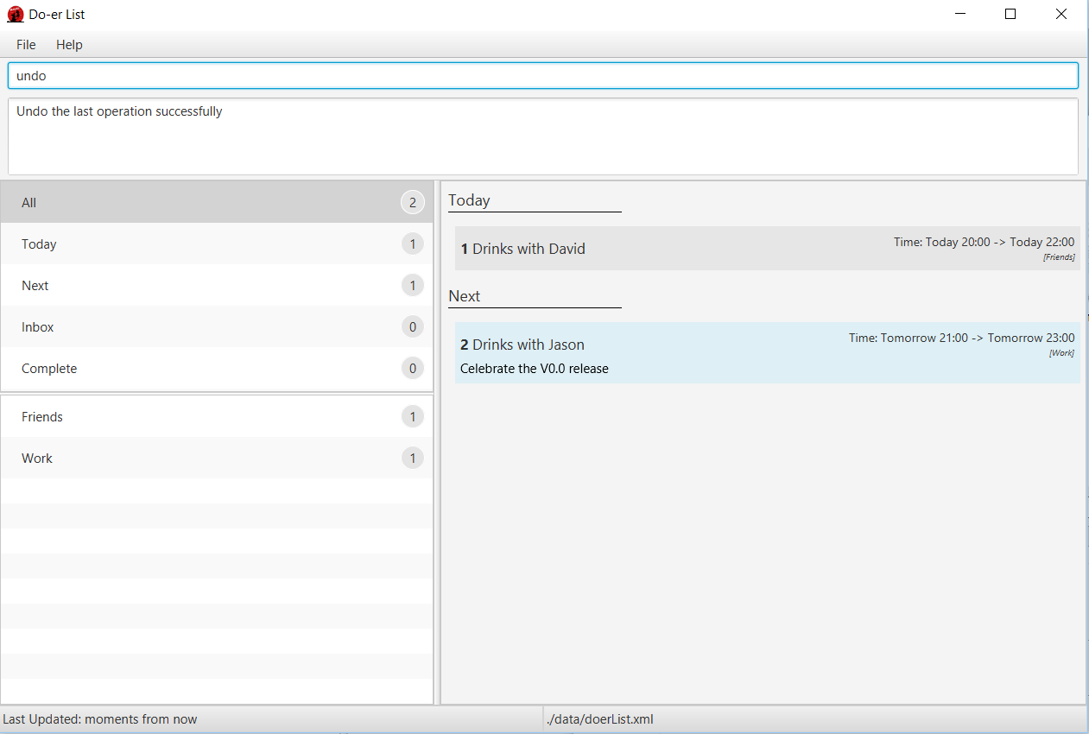

Redo the most recent operation: redo
Redo the most recent undo
Format: redo

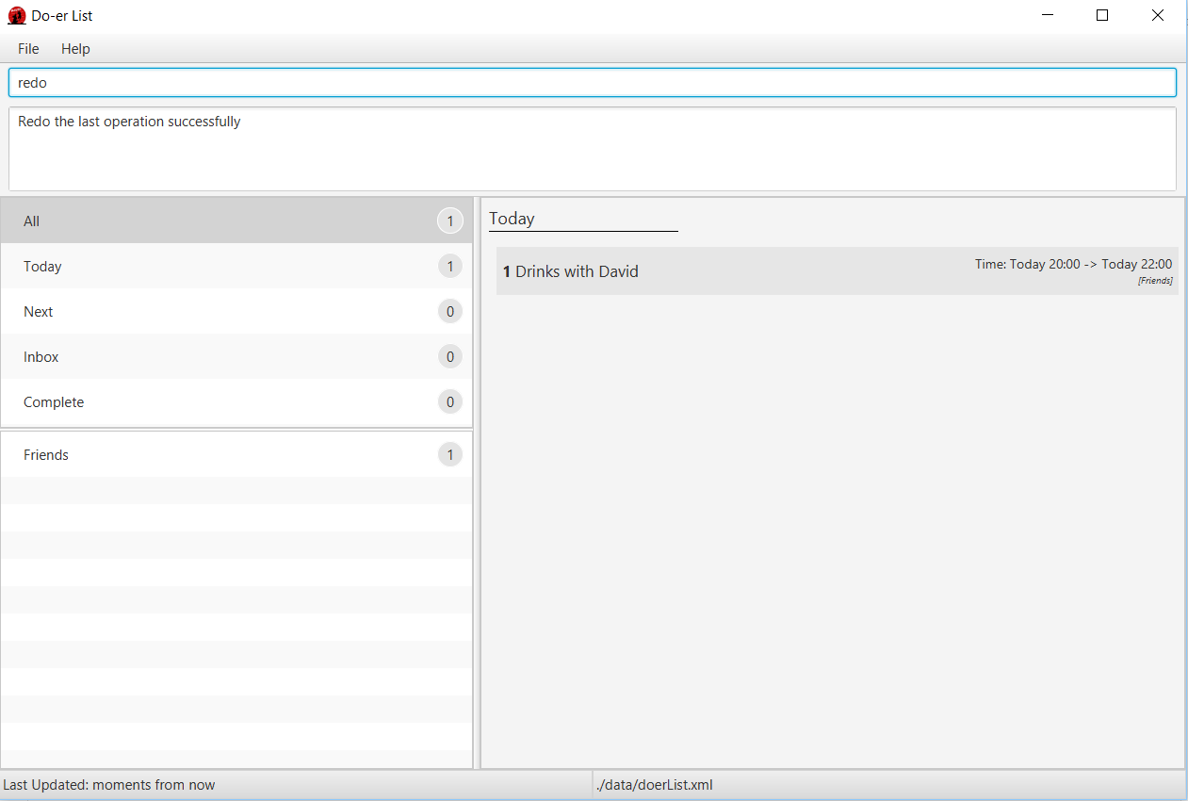
An undo command must first be used before redo command can be executed.

Find all tasks due: taskdue
Finds all tasks due on and before the date specified in the Doer-list.
Format: taskdue END_DATE

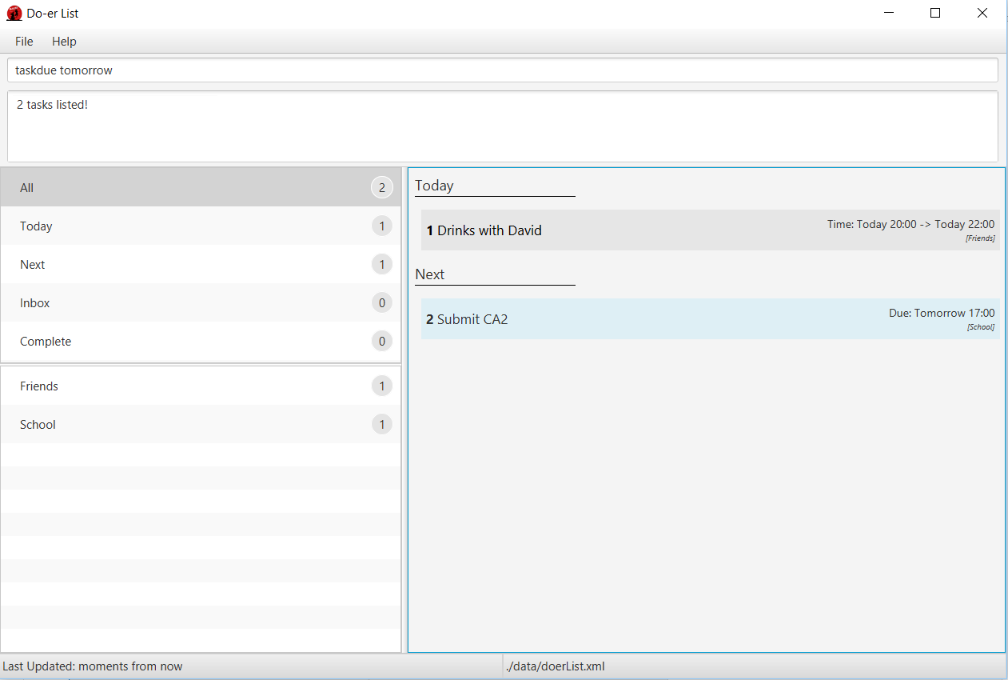
- Finds all tasks due on and before END_DATE.
- The date can be in natural language*.
- Supported list for natural language*:
  - next X hours / days / weeks / months
    - X can be any number: 1, 2, 3, ...
  - today
  - tomorrow
  - next week / month
Examples:
- taskdue tomorrow
- taskdue next 5 hours
- taskdue 2016-11-11 21:03

Changing your save location: saveto
Save the data into a new file and location
Format: saveto NEW_LOCATION

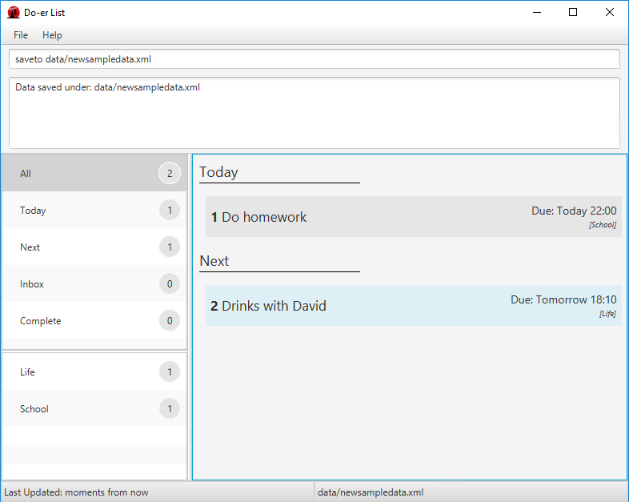
Examples:
- saveto data/newsampledata.xml

Automatic save
The Doer-list data are saved in the hard disk automatically after any command that changes the data.

Exiting the program: exit
Exits the program.
Format: exit

FAQ
Q: How do I transfer my data to another computer?
A: Install the app in the other computer and overwrite the empty data file it creates with the file that contains the data of your previous Do-er List folder.
Q: Running "doerlist.jar" gives and error or does not seem to work.
A: You will need to install the latest version of Java. Refer to the installation guide here.
Q: Where is the save button for me to save my schedule in this program?
A: Your data are saved in the hard disk automatically after any command that changes the data as aforementioned here in the guide. There is no need for you to save it manually.

Command Summary
Command | Format
Help | help [COMMAND]
Add | add /t TITLE [/d DESCRIPTION] [/s START] [/e END] [/c CATEGORY]  [/r RECURRING] ...
Edit | edit INDEX [/t TITLE] [/d DESCRIPTION] [/s START] [/e END]  [/c CATEGORY] [/r RECURRING] ...
Mark Done | mark TASK_NUMBER
Mark Undone | unmark TASK_NUMBER
List | list [CATEGORY]
Find | find KEYWORD [MORE_KEYWORDS]
View | view INDEX
Delete | delete INDEX
Undo | undo
Redo | redo
Task Due | taskdue END_DATE
Save | saveto NEW_LOCATION
Exit | exit

Developer Guide

Appendix A: …

Appendix B: …

